Above is the plot (data below) of number of clusters as a function of pore probability, p. As p increases until 0.3, the number of unique labels and clusters increases. This is because the probability of an open pore occurring in succession is low and therefore the pores cannot be relabeled to the minimum of a nearest neighbor and are closed off by closed sites. After p = 0.3, the number of clusters continues to constantly decrease until to below 10 clusters/unique labels as the number of site are more likely to have open pores. As the probability increases, the number of sites that are neighbors increase and therefore once relabeled, show that the lattice is percolating and ultimately the number of clusters drop significantly. The number of clusters grew as lattice size increased due to the sheer number of sites. P incremented by .5 in [.1,.95].

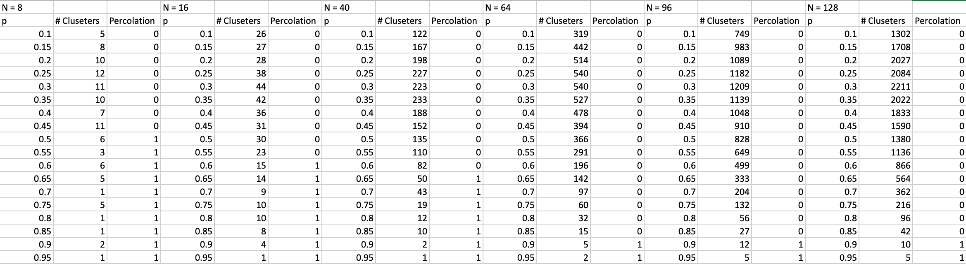

The graph above shows percolation transition as a function of the lattice size. With lower lattice sizes, a lower probability of open pores is required to obtain a percolating system. Based on the lattice sizes tested, there needed to be at least a probability of 0.5 to obtain a percolating system. As the number of pores approach a 2x2 lattice, the system is more likely to percolate with a lower probability. However, even with large lattice sizes, it seems that a probability of 0.9 yields a percolating system. Although there is a general increase of percolation transition at higher probabilities with larger lattice sizes, there are both maximum and minimum probabilities for respective lattice sizes. Therefore, within bounds, there is a dependence of percolation transition on lattice size.